Medical Diagnosis Center
Project Description:
The Medical Diagnosis Center is a ServiceNow-based digital diagnostic test management system designed to streamline patient registration, diagnostic test selection, appointment booking, approval management, laboratory processing, report generation, notifications, security and administrative reporting. The solution uses ServiceNow custom tables, Service Portal pages and widgets, Business Rules, Flow Designer workflows, ACLs, notifications, reports and dashboards to provide a centralized diagnostic-center workflow.
Patients can browse the Test Catalog, provide patient information, select an appointment date and time, track appointment status and access authorized laboratory reports. Staff roles such as receptionists, laboratory technicians, doctors, lab managers and administrators support the operational lifecycle through configured ServiceNow functionality.

Scenario 1: Patient Registration and Diagnostic Test Selection
A patient opens the Medical Diagnosis Center Service Portal, enters required patient information and browses configured diagnostic tests. Test records can contain the test name, code, category, description, price, duration and active status. The patient then selects an appropriate test before booking.

Scenario 2: Appointment Booking, Approval and Processing
After selecting a test, the patient chooses an appointment date and time slot. The system is designed to validate mandatory fields, availability, duplicate and overlapping bookings, configured capacity and other booking rules. The appointment can move through Requested, Pending Approval, Confirmed, Sample Collected, Processing and Completed states.

Scenario 3: Report Availability and Secure Access
When diagnostic processing is completed, a report can be generated and linked to the appointment and patient. A configured notification can inform the patient when the report becomes available. ACLs and patient-specific access controls are used to restrict report and application data access.
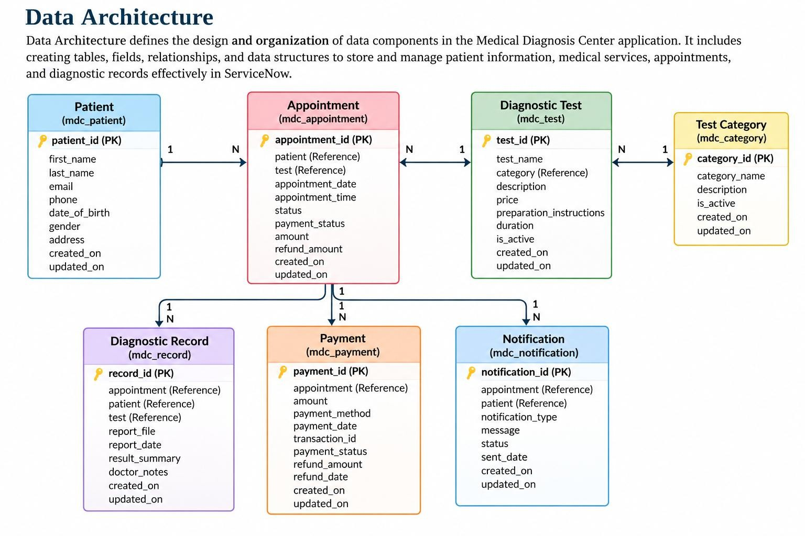
SERVICENOW ARCHITECTURE

Entity Relationship (ER) Diagram:

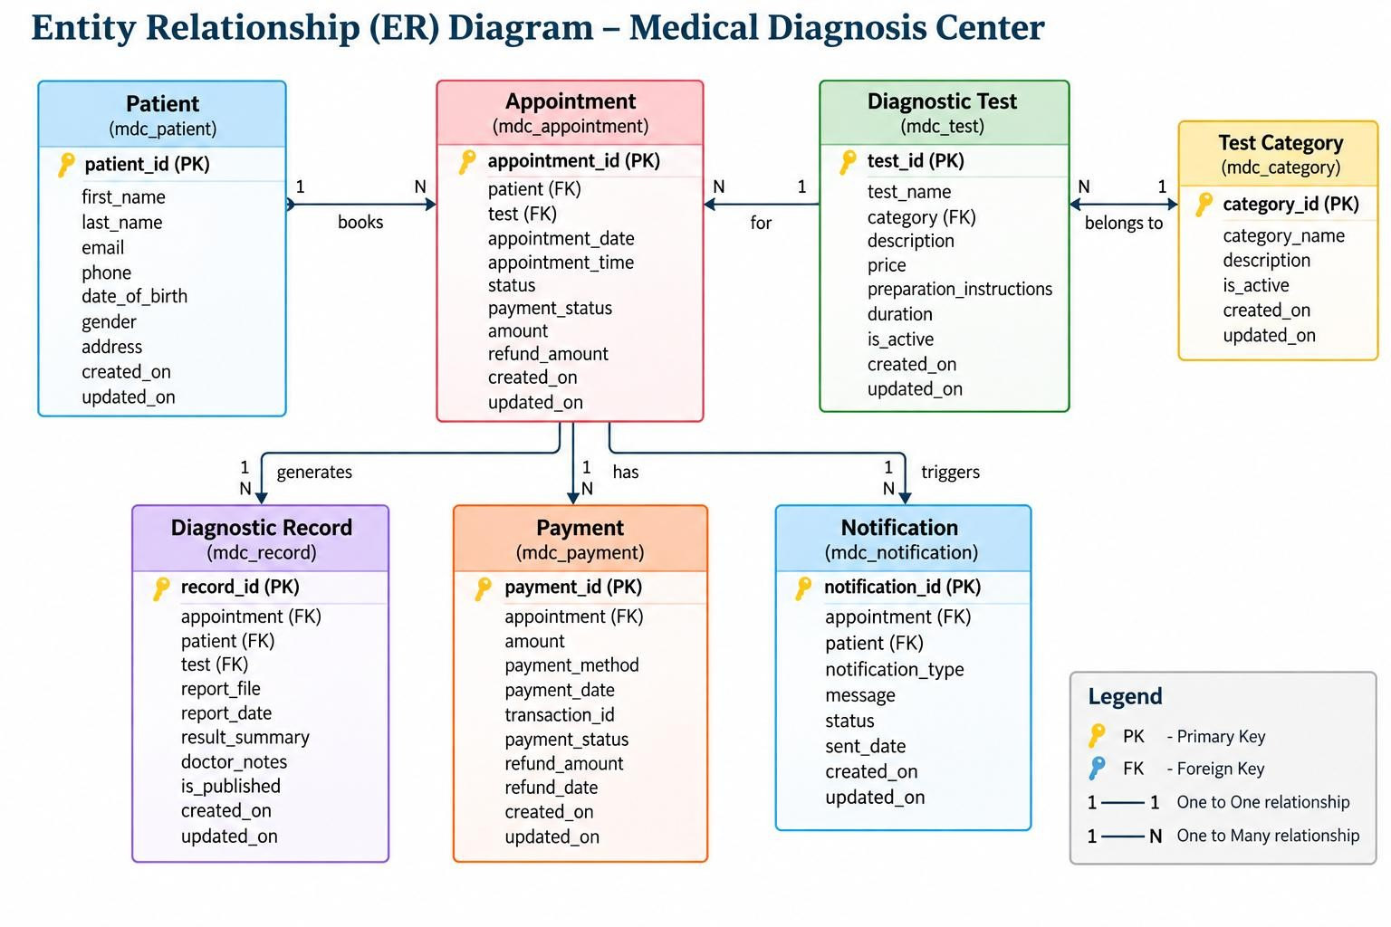

Pre
-
requisites:

- ServiceNow instance
- Service Portal enabled
- Access to Studio / Scoped Application Development
- Appropriate ServiceNow roles
- Access to Email Notifications, Business Rules, ACLs and Reports & Dashboards
- Access to Update Sets and application deployment configuration Project WorkFlow:
- 1. ServiceNow instance and application setup
- 2. Create custom tables and relationships
- 3. Design Service Portal pages and widgets
- 4. Create diagnostic test catalog
- 5. Implement patient registration
- 6. Implement appointment booking and validation
- 7. Configure approval and status workflow
- 8. Configure laboratory processing and report generation
- 9. Configure email notifications
- 10. Configure payment/refund logic as enabled
- 11. Configure ACL security and patient-specific access
- 12. Create reports and Health Reports Dashboard
- 13. Test the end-to-end workflow and validate Update Set deployment

Milestone 1: ServiceNow Instance and Application Setup
● Activity 1.1: Open the ServiceNow instance
• Sign in to the configured ServiceNow instance and verify that the required roles and application development access are available.
● Activity 1.2: Open the Medical Diagnosis Center application
• Open the application development area and verify the Service Portal, tables, scripts, notifications, ACLs and reporting components required for the project.
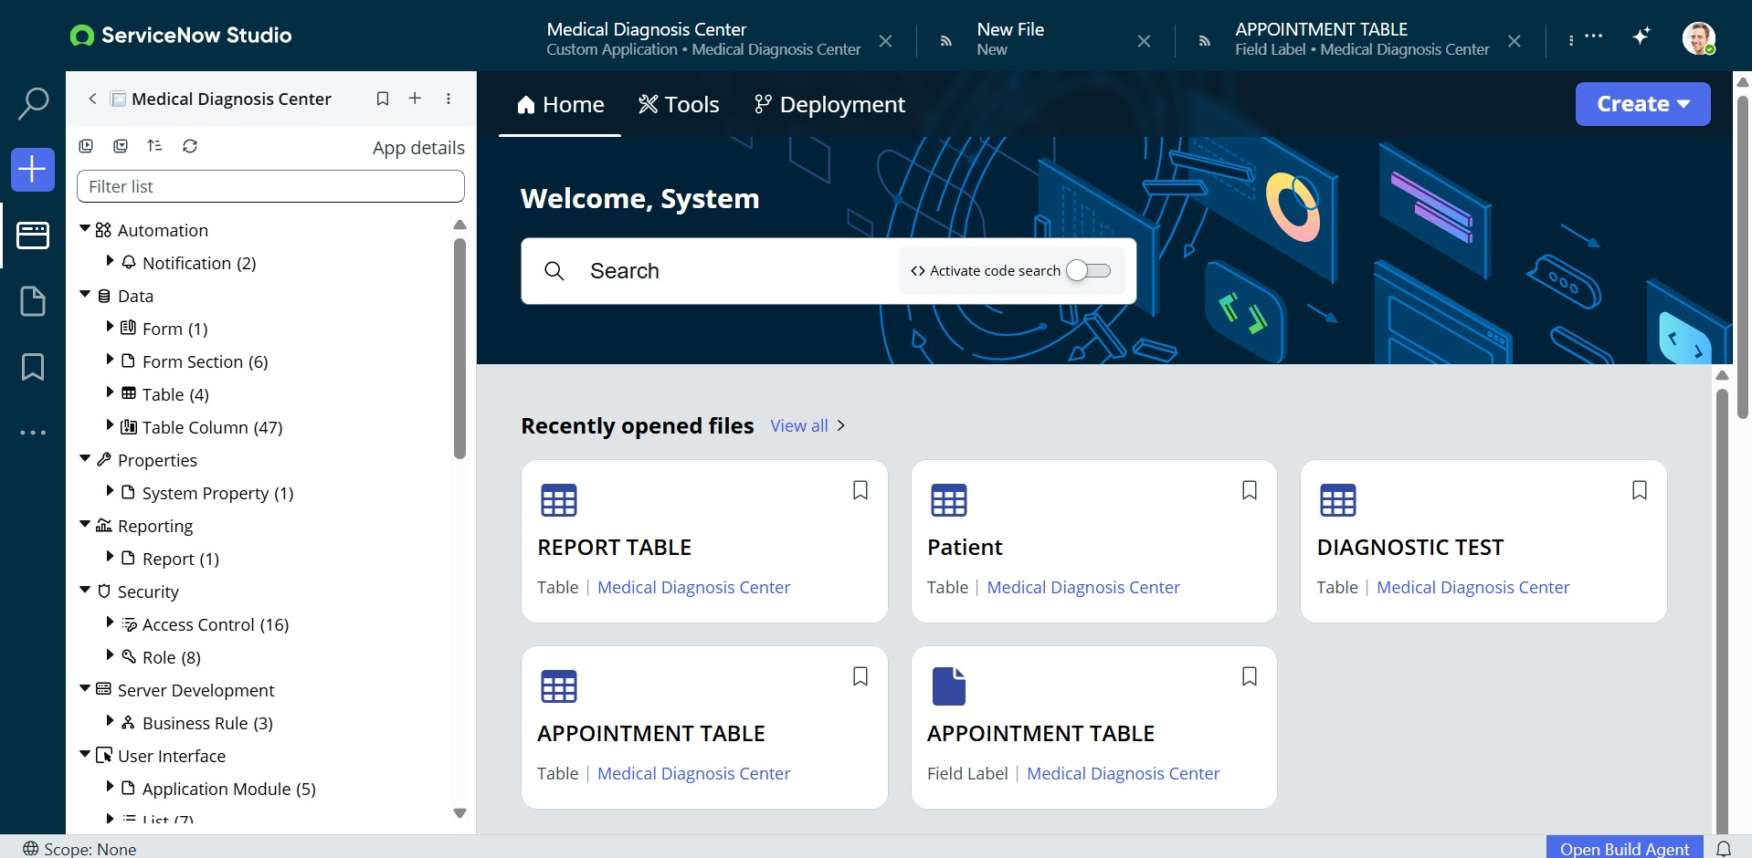

Milestone 2: Custom Table Creation and Setup
● Activity 2.1: Create the core Medical Diagnosis Center tables
- Create the Patient table to store patient information.
- Create the Diagnostic Test table to store test details.
- Create the Appointment table to store booking and lifecycle information.
- Create the Report table to store diagnostic report information.
- Create the Payment table to store payment information where the phasebased feature is enabled.
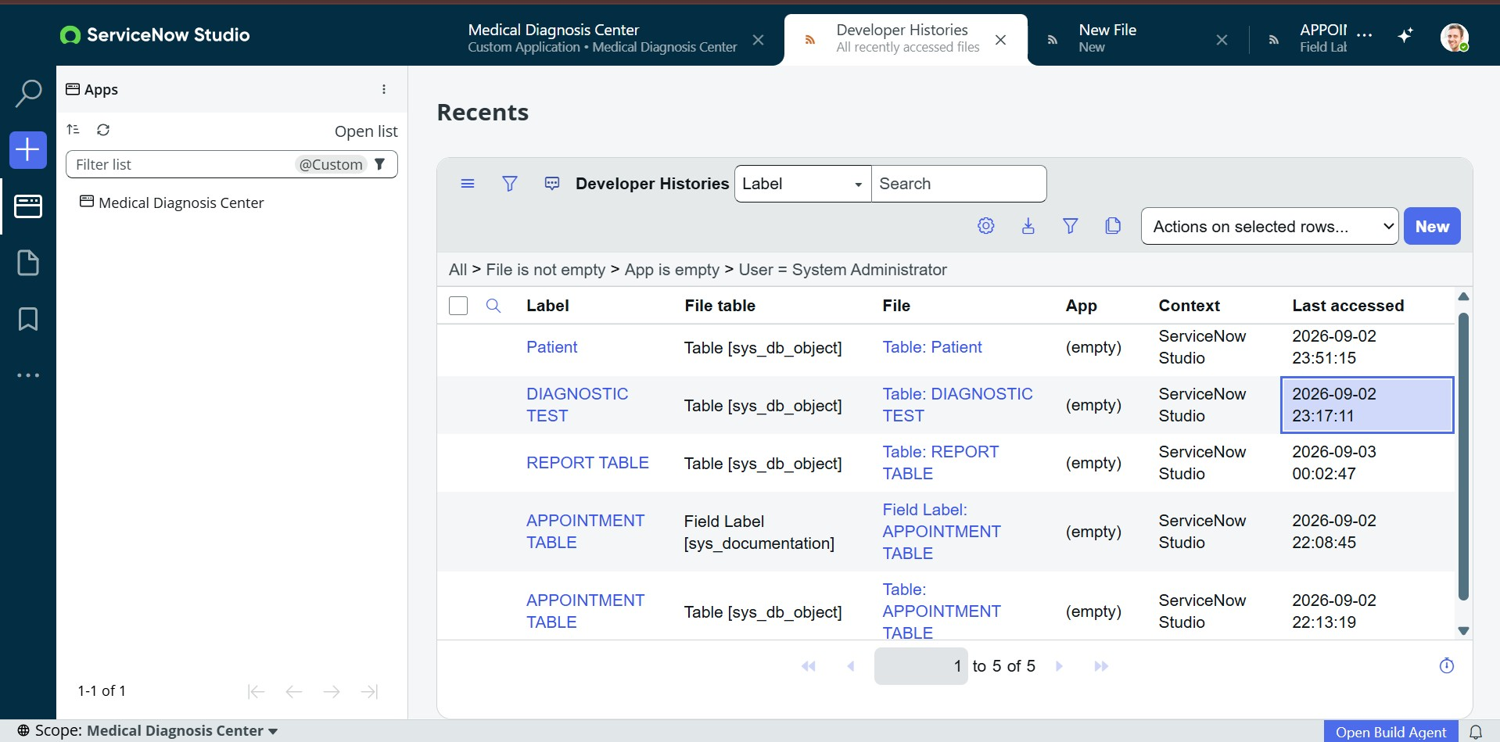

Activity 2.2: Patient and Diagnostic Test Tables
Patient Table
Field / Area | Purpose
Patient Information | Stores required patient details.
Contact Information | Stores contact number and email address.
Patient Identity | Provides the patient record referenced by appointments and reports.
Diagnostic Test Table
Field | Purpose
Test Name | Name of the diagnostic test.
Test Code | Unique configured code for the test.
Category | Diagnostic category.
Description | Description of the test.
Price | Configured test price.
Duration | Configured test duration.
Active Status | Controls whether the test is available.
Activity 2.3: Appointment, Report and Payment Tables
Table | Purpose | Main Relationships
Appointment | Stores booking,  date/time, status, approval and paymentrelated information. | Patient + Diagnostic  Test + Payment +  Report
Report | Stores diagnostic report information and report lifecycle data. | Patient + Appointment
Payment | Stores payment status and configured transaction information. | Appointment
Data Relationships
Patient → Appointment → Diagnostic Test / Payment / Report Milestone 3: Service Portal Setup
● Activity 3.1: Create the Service Portal pages
- Home Page
- Test Catalog Page
- Book Appointment Page
- My Appointments Page
- Lab Reports Page
- Payment Page (phase-based)
- Admin Dashboard Page
The Service Portal provides the patient-facing interface for the diagnosticcenter workflow.
Diagnostic Test Catalog
The Medical Test Catalog Widget displays available diagnostic tests. Test information can include name, code, category, description, price, duration and active status.
Test Name | Code | Category | Price | Duration
Complete  Blood Count  (CBC) | CBC-001 | Blood Test | ₹45 | 30 minutes
Lipid Profile | LIP-002 | Blood Test | ₹60 | 30 minutes
HbA1c  (Diabetes) | HBA-003 | Blood Test | ₹70 | 30 minutes
Thyroid  Function Test  (TFT) | THY-004 | Blood Test | ₹95 | 30 minutes
Liver  Function Test  (LFT) | LFT-005 | Blood Test | ₹75 | 30 minutes
Kidney  Function Test  (KFT) | KFT-006 | Blood Test | ₹65 | 30 minutes

Appointment Booking
The Appointment Booking Widget allows patients to select a diagnostic test, choose an appointment date and time slot, enter patient details and submit an appointment request.
Patient Details
- Full Name
- Age
- Gender
- Contact Number
- Email Address
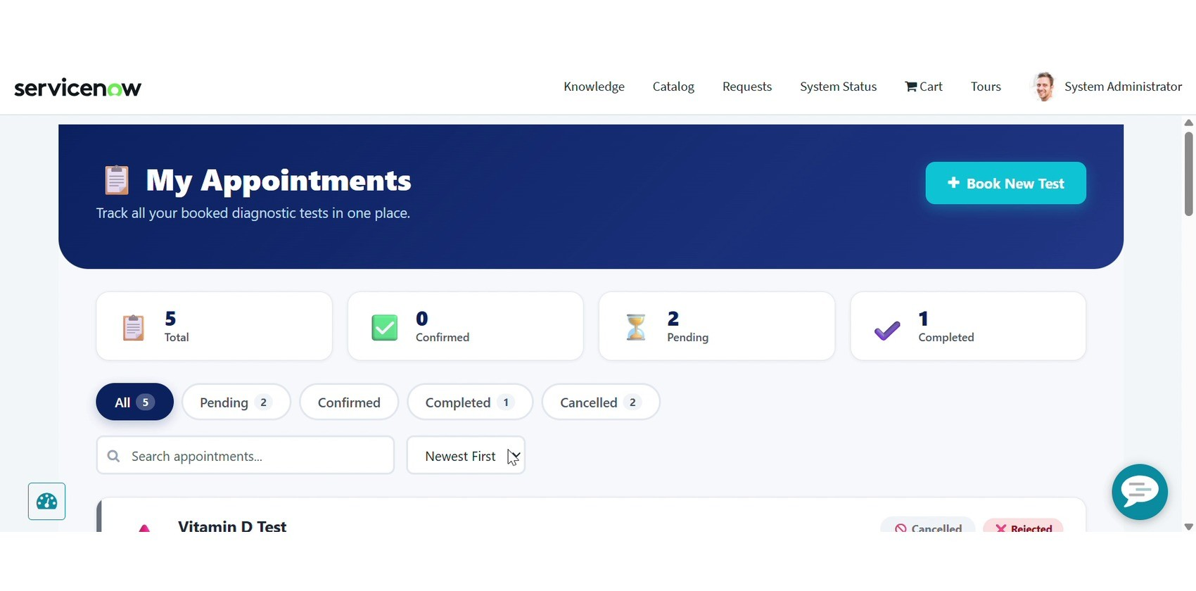

Appointment Validation
The system is designed to validate appointment information before a booking is accepted.
- Mandatory-field validation
- Available test slots
- Duplicate booking prevention
- Overlapping appointment prevention
- Equipment conflict prevention
- Technician conflict prevention
- Capacity control per time slot
- Maximum number of tests per patient per day
- Advance booking limits
- Cut-off time restrictions
Example: A time slot can be configured with a maximum number of patients per hour. Once the configured capacity is reached, additional bookings can be prevented.

Milestone 4: Approval and Status Management
Appointments can be managed through configured approval and lifecycle states.
Requested → Pending Approval → Confirmed → Sample Collected →
Processing → Completed → Report Available
Alternative lifecycle outcome: Cancelled
Approval handling can record approval notes and Approved By. Rejection handling can record the rejection reason and clear Approved By.
Appointment Status Lifecycle
Status | Purpose
Requested | Initial appointment request.
Pending Approval | Waiting for configured approval.
Confirmed | Appointment approved/confirmed.
Sample Collected | Patient sample collection completed.
Processing | Laboratory processing is in progress.
Completed | Diagnostic processing completed.
Report Available | Report is available to authorized users.
Cancelled | Appointment cancellation outcome.

Milestone 5: Email Notification Setup
Activity 5.1: Approval Notification
Configuration | Value
Name | Approval Notifications
Table | x_2056490_medica_0_appointment_table
When to Send | Record Inserted or Updated
Condition | Approval Status changes to Approved
Active | True
Activity 5.2: Report Notification
Configuration | Value
Name | reportsNotifications
Table | x_2056490_medica_0_report_table
When to Send | Record Inserted
Condition | Report number is Not Empty
Active | True

Diagnostic Report Management • 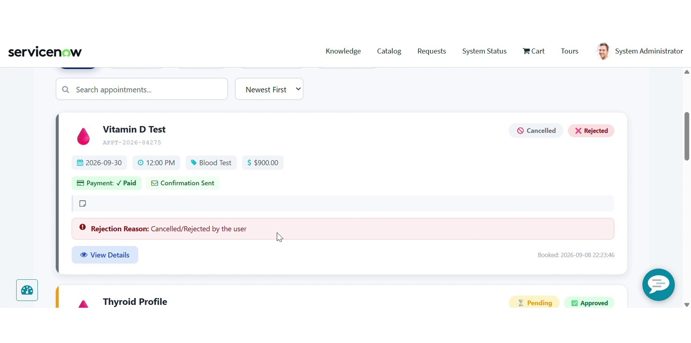 Report Lifecycle and Lab Reports
Diagnostic reports are linked to appointments and patients. The report workflow supports report generation after diagnostic processing and makes completed reports available to authorized users.
- Create/link report to appointment
- Link report to patient
- Generate report number
- Record report date
- Record verifier
- Set report status
- Expose report through Lab Reports functionality
Report Lifecycle
Sample Collected → Processing → Completed → Report Generated → Report Available
The Lab Reports Widget allows patients to view available reports, view report details and download reports where configured.
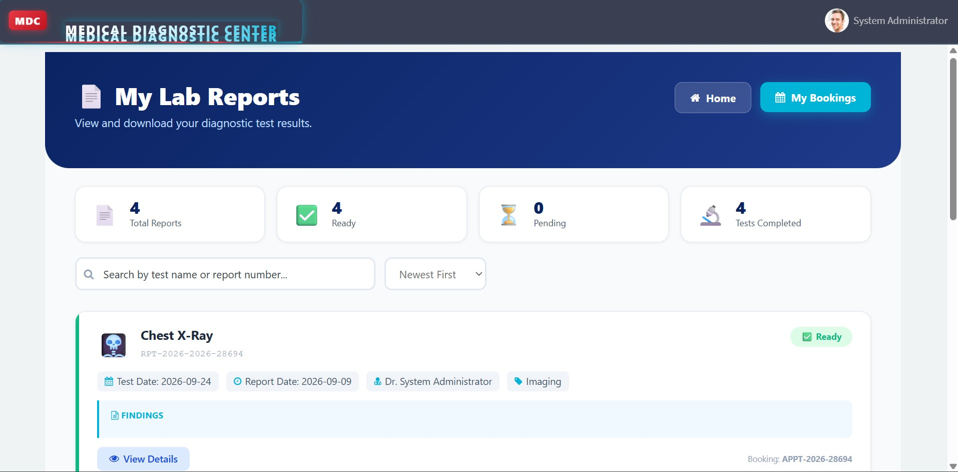

Payment Management
Payment functionality is designed as a phase-based feature. When enabled, it can support test-based pricing, payment status, online payment, digital invoice generation, receipts and transaction history.
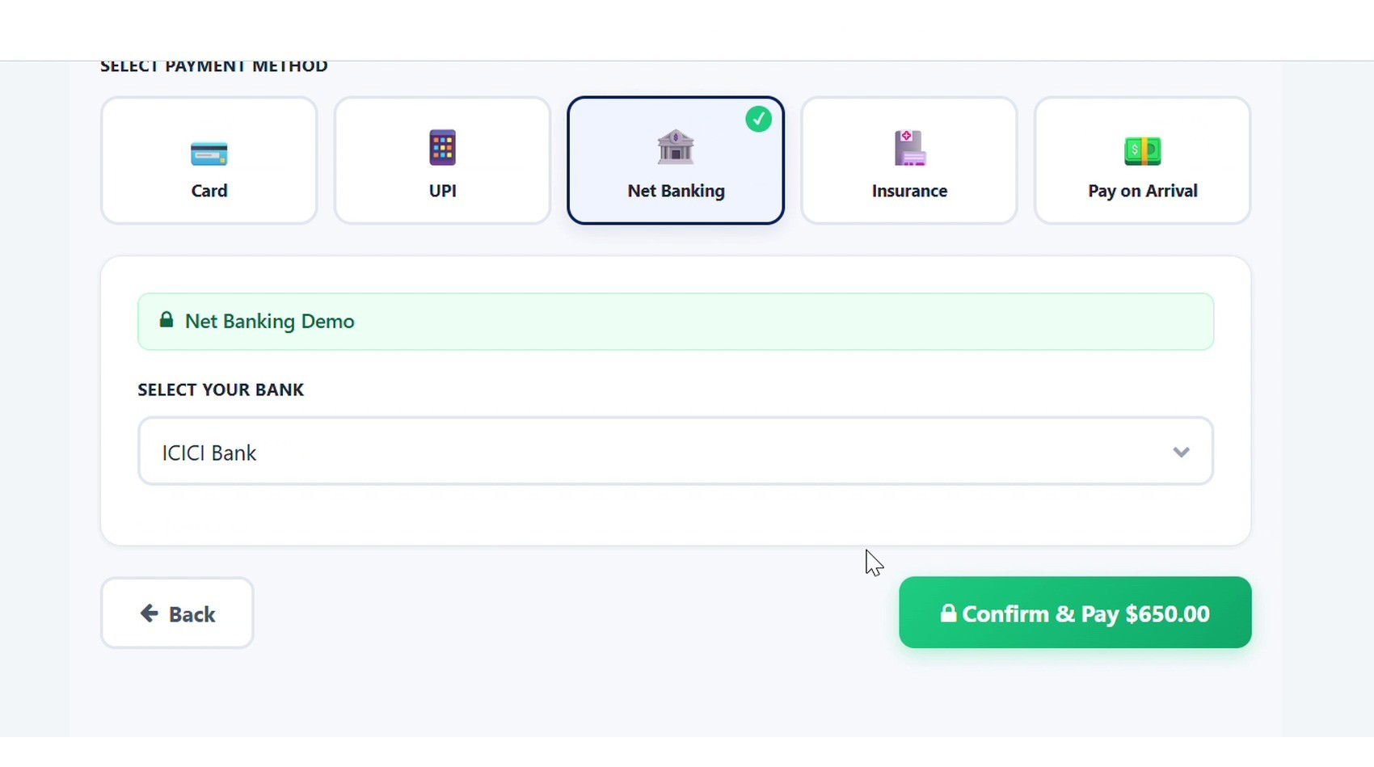
Payment Method Selection
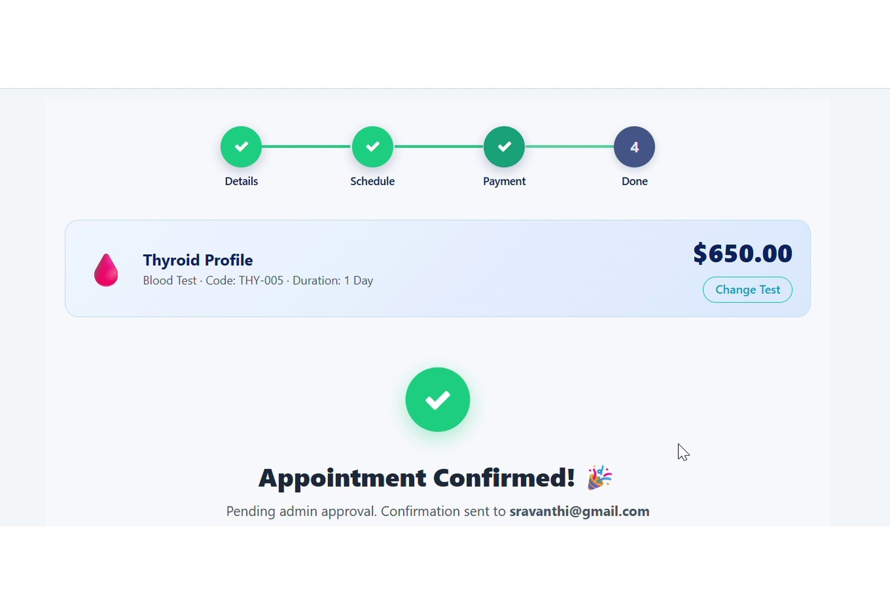
Appointment Confirmation
- Automatic fee calculation
- Test-type based pricing
- Normal / Express urgency
- Home collection charges
- Online payment
- Payment status tracking
- Digital invoice generation
- Payment receipts
- Transaction history
Payment Status: Paid | Pending | Failed

Cancellation and Refund
The configured cancellation Business Rule applies a 10% deduction from the total amount.
Example
Item | Amount
Total Amount | ₹500
10% Deduction | ₹50
Refund Amount | ₹450
The refund amount is automatically populated when the configured cancellation condition is satisfied.

Business Rules and Automation

1. Auto Populate Refund Amount on Cancellation
When an appointment is cancelled, the Business Rule reads the total amount, calculates the 10% deduction, calculates the remaining refund and stores the refund amount.

2. Auto Create Report on Appointment Complete
When an appointment changes to Completed, the system can create a report if one does not already exist, generate a report number, retrieve diagnostic test information, generate findings, link the report to the appointment and patient, record report date and verifier, and set report status.

3. Rejection Details Updation
When an appointment is rejected, the rejection reason is populated and Approved By is cleared. When approved, the approval note is recorded, Approved By is populated and rejection reason is cleared. Flow Designer / Workflow Automation
Flow Designer workflows can be used to automate configured diagnosticcenter processes such as appointment approval, status transitions, notifications and report-related actions.
- Trigger based on appointment changes
- Validate or route approval
- Update appointment status
- Send configured notifications
- Support report availability communication
- Coordinate lifecycle actions

Milestone 6: Security and ACL Configuration
The application uses Access Control Lists (ACLs) to control access to application data.
- Table-level access control
- Field-level access control
- Role-based access
- Patient-specific record access
- Appointment creation permissions
- Laboratory report access restrictions
- Administrative access restrictions
- Impersonation testing
- Debug Security Rules validation

Roles and Stakeholder Access
Role | Main Responsibilities
Patient | Register, browse tests, book appointments, view status and access authorized reports.
Receptionist | Create/update patient records and coordinate appointments.
Laboratory Technician | Review approved appointments, collect samples and update processing status.
Doctor | Review diagnostic information/report data where configured.
Lab Manager | Review specialized/high-value appointments, approve/reject where configured and monitor status.
System Administrator | Configure tables, forms, portal pages, widgets, Business Rules, ACLs, notifications, reports, dashboards and Update Sets.
Milestone 7: Update Set and Deployment Preparation
The project uses ServiceNow Update Sets for capturing application configuration for deployment.
- Create/update the Update Set
- Capture relevant application configuration
- Validate captured records
- Commit the Update Set
- Transfer configuration to the target instance
- Validate the target instance
- Perform smoke testing
- Monitor system logs and application behavior

Application Development Components
Technology / Component | Usage
ServiceNow | Application platform
Service Portal | Patient-facing interface
JavaScript | ServiceNow scripting
GlideRecord | Server-side record operations
HTML | Portal UI
CSS | Portal styling
AngularJS | Service Portal client-side development
Business Rules | Automation
Flow Designer | Workflow automation
ACLs | Security
Reports & Dashboards | Analytics
Update Sets | Deployment
Git / GitHub | Version control

Service Portal Pages
Page | Purpose
Home Page | Main landing page for the Diagnostic Center
Test Catalog Page | Displays available diagnostic tests
Book Appointment Page | Allows patients to book diagnostic tests
My Appointments Page | Displays patient appointment details and status
Lab Reports Page | Allows patients to view/download diagnostic reports
Payment Page | Handles payment-related  functionality as a phase-based feature
Admin Dashboard Page | Provides administrative reports and analytics
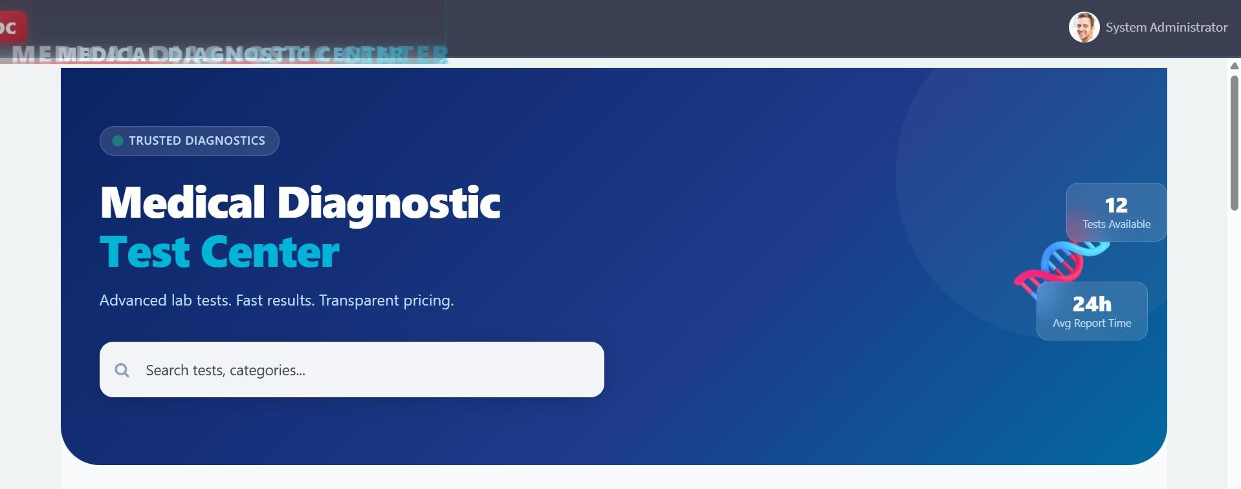

ServiceNow Widgets
1. Medical Test Catalog Widget
Displays configured diagnostic tests and their details.

2. Appointment Booking Widget
Supports test selection, appointment date/time selection, patient details and booking validation.

3. My Appointments Widget
Displays appointments, status, approval status and permitted cancellation/rescheduling actions.

4. Lab Reports Widget
Displays available diagnostic reports and supports viewing/downloading where configured.

Medical Test Catalog Widget
Test Information
- Diagnostic Test Name
- Test Code
- Test Category
- Description
- Price
- Duration
- Active Status
Configured examples include CBC, Lipid Profile, HbA1c, Thyroid Function
Test, Liver Function Test, Kidney Function Test, Urine Routine & Microscopy, Chest X-Ray, ECG, COVID-19 PCR Test, Vitamin D Test and Iron Studies.

Appointment Booking Widget
The Appointment Booking Widget allows patients to:
- Select a diagnostic test
- Select an appointment date
- Select a time slot
- Enter patient details
- Submit an appointment request
- Validate mandatory information
- Check booking availability

Milestone 8: Testing and Deployment Validation
Activity 8.1: Conduct functional testing to verify patient registration, diagnostic test selection, appointment booking, validation, approval, laboratory processing, report generation, notifications, cancellation/refund, ACL security and dashboard reporting.
Test ID | Scenario | Expected Result | Status
TC-001 | Register patient | Patient record created | Pending / to be recorded
TC-002 | Book diagnostic  test | Valid appointment saved; conflicts blocked | Pending / to be recorded
TC-003 | Approve appointment | Confirmed status and notification | Pending / to be recorded
TC-004 | Process appointment | Lifecycle progresses correctly | Pending / to be recorded
TC-005 | Generate report | Report linked to appointment/patient | Pending / to be recorded
TC-006 | Cancellation/refund | 10% deduction applied | Pending / to be recorded
TC-007 | ACL access | Unauthorized access denied | Pending / to be recorded

Home Page:
Service Portal Home Page
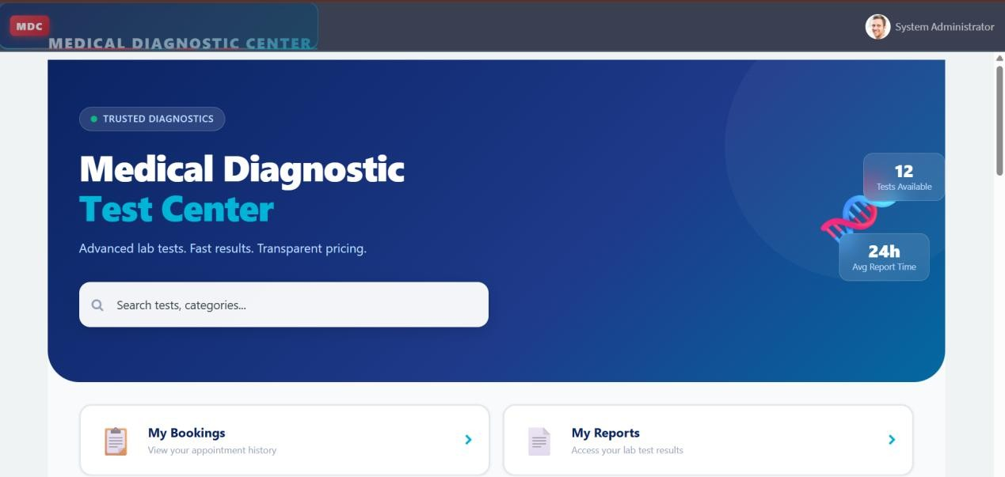
The Home Page acts as the main landing page for the Medical Diagnosis Center Service Portal.

Dashboard Page:
My Bookings
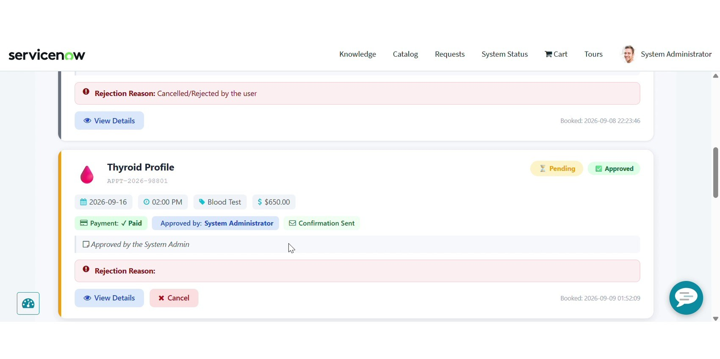
The patient dashboard can display appointment information, status and configured actions.
Test Catalog Page:
Medical Test Catalog
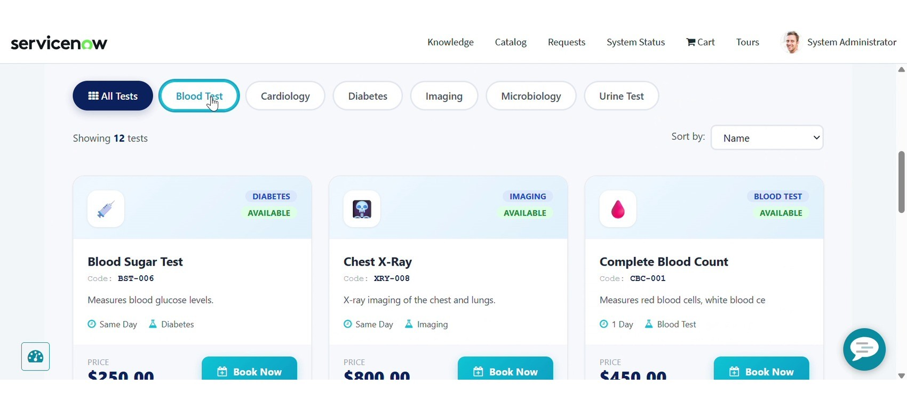

Book Appointment Page:
Book Appointment
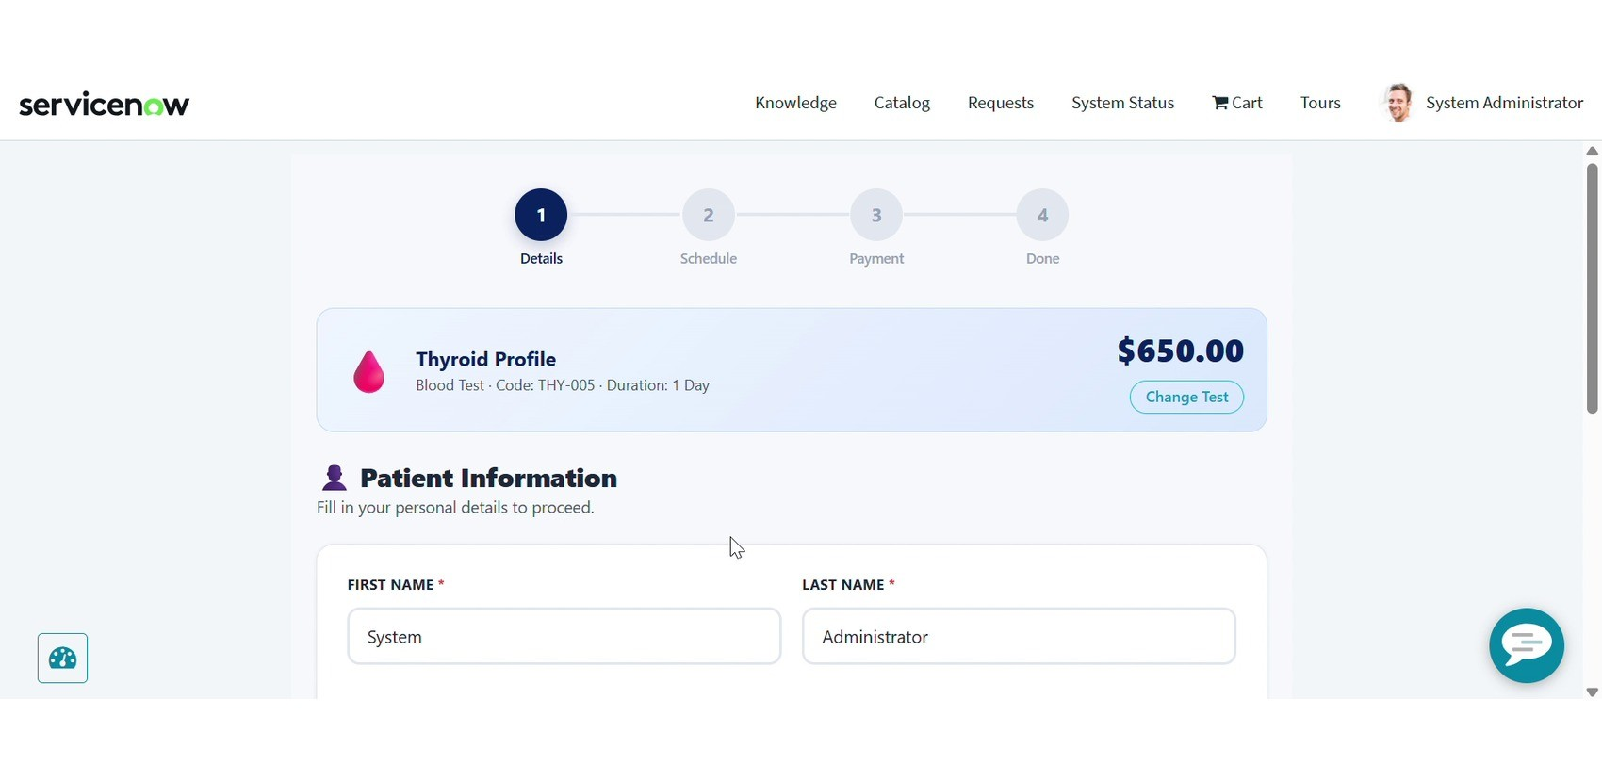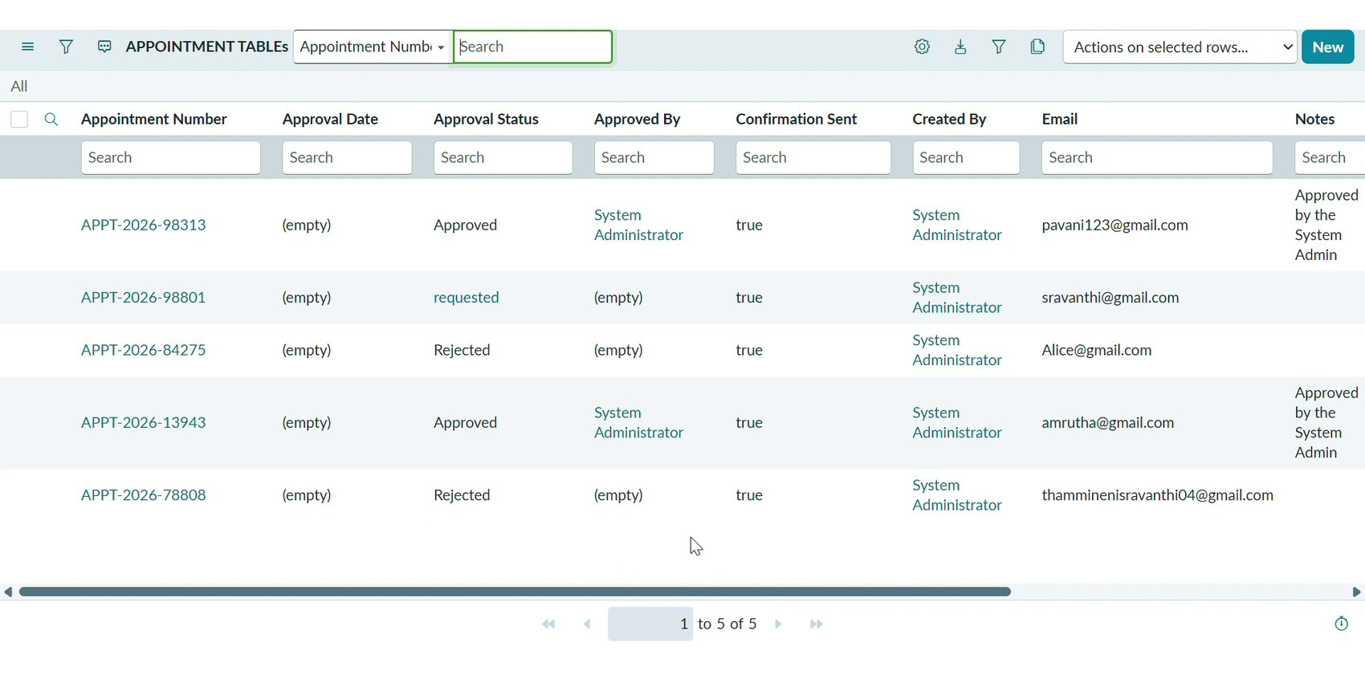
Insert the implemented Service Portal screenshot showing diagnostic test selection, date/time selection and booking controls.

Appointment Details / Validation Page:
Appointment Details
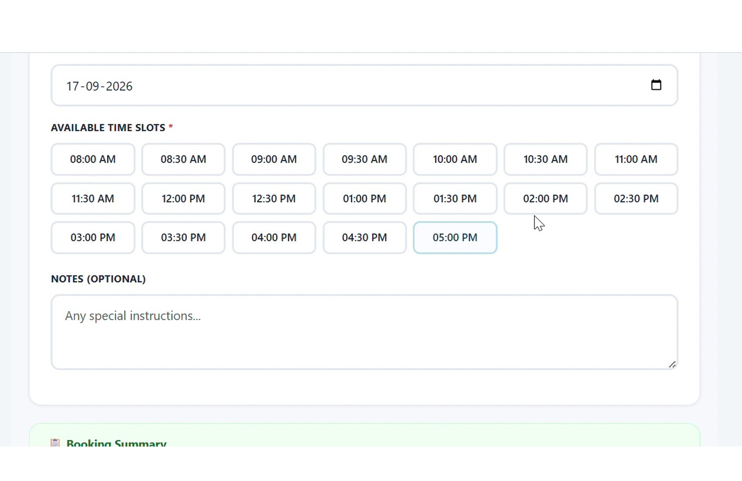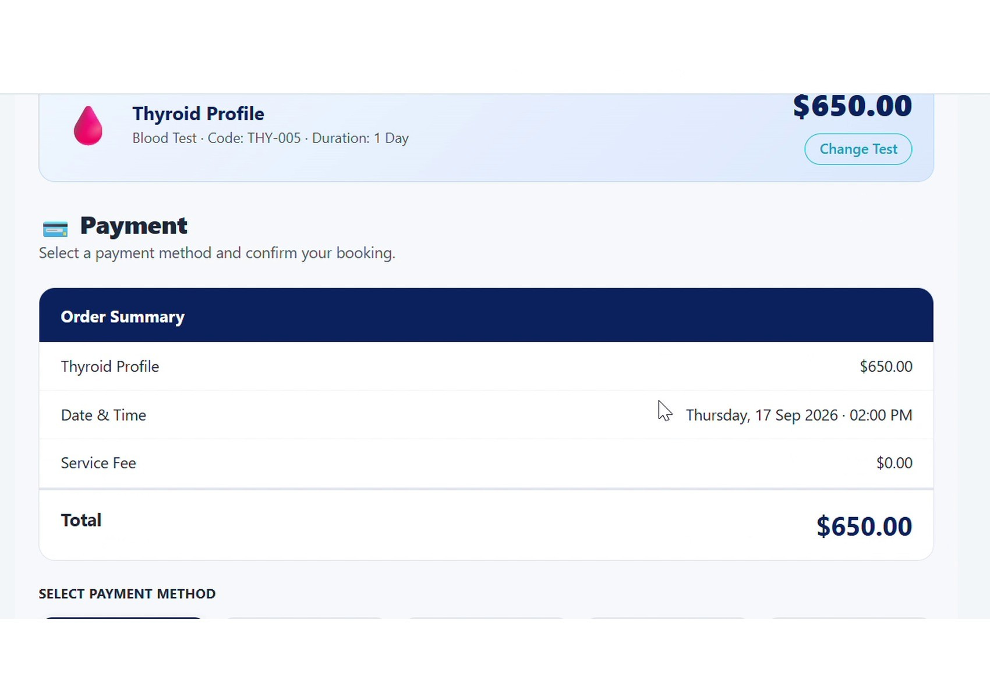
Approval and Processing Page:
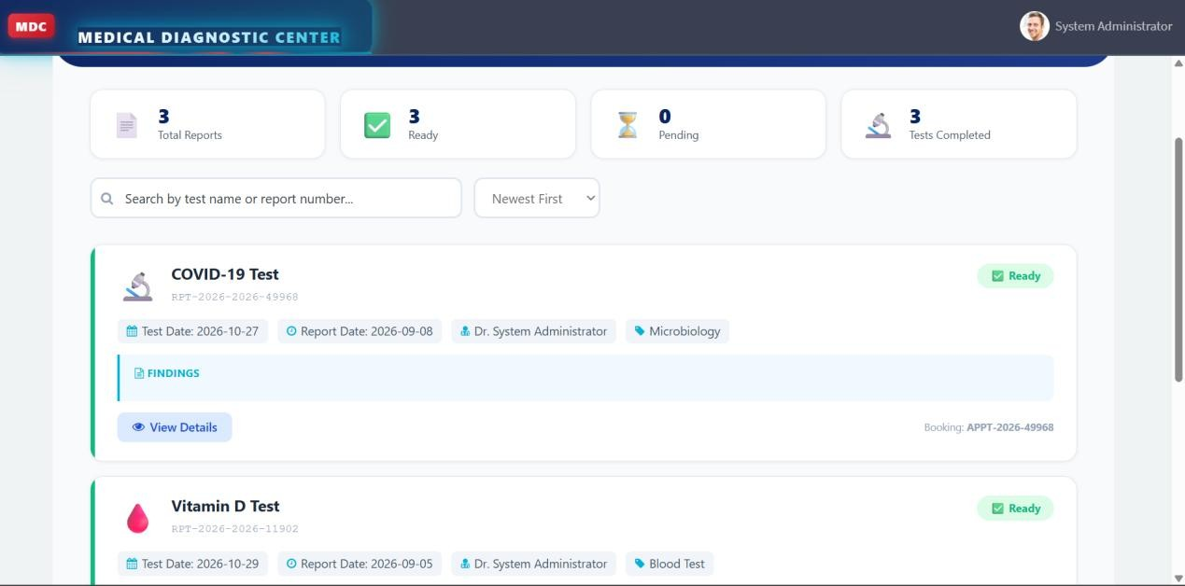
Lab Reports Page:
My Reports
Insert the implemented report view showing the authorized patient's diagnostic report.

Payment / Cancellation Page:
payment details

If payment is enabled in the implemented phase, insert the payment evidence. Otherwise insert the configured cancellation/refund record.
Health Reports Dashboard:
My Reports

Dashboard Name: Health Reports Dashboard
Appointments Reports can group appointment data by Status and Approval Status, with configured aggregation and dashboard placement.
ServiceNow Data and Notifications

1. Appointment Records
Appointment records contain patient, diagnostic test, date/time, status, approval and configured payment/report information.

2. Diagnostic Report Records
Report records are linked to the relevant appointment and patient and can become available after completion.

3. Mail to the User
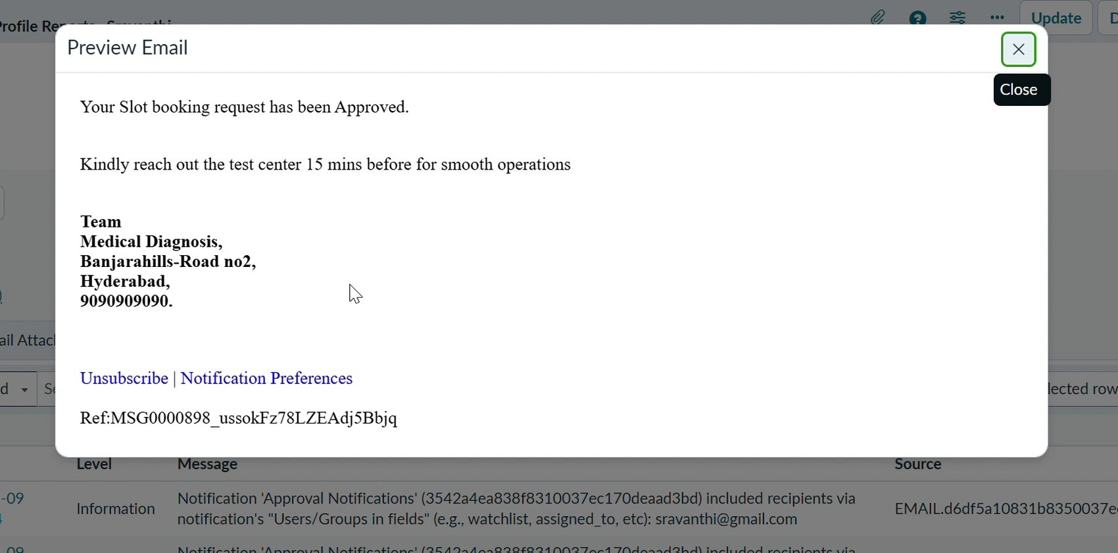

Email Notification Preview
Configured email notifications can communicate appointment approval and report availability. Additional scenarios include booking confirmation, payment confirmation, rejection, reminders, cancellation and refund notifications where configured.

Student Name: Thammineni Sravanthi
Project: Medical Diagnosis Center

Conclusion:
The Medical Diagnosis Center has been designed as a centralized ServiceNow workflow for patient registration, diagnostic test selection, appointment management, laboratory processing, report delivery, notifications, security and operational reporting. The solution connects these activities through custom tables, Service Portal pages and widgets, Business Rules, Flow Designer workflows, ACLs, notifications and dashboards.
The configured appointment lifecycle supports Requested, Pending Approval, Confirmed, Sample Collected, Processing, Completed and Report Available states, with Cancellation as an alternative outcome. The project documentation also defines validation rules, report management, phase-based payment/refund handling, role-based security and management reporting.
The solution is intended to reduce manual paperwork and duplicate data entry, centralize patient and diagnostic information, improve appointment coordination, automate configured approval and notification processes, protect sensitive records through access controls and provide operational visibility through reports and dashboards.
Final execution screenshots and actual test results should be inserted from the implemented ServiceNow instance. The supplied project materials explicitly leave execution measurements pending where they were not provided.

Project Outcome
The Medical Diagnosis Center provides a structured ServiceNow workflow for managing diagnostic-center operations from patient registration through appointment booking, approval, laboratory processing and report availability.

